***Selenium Grid:***

Selenium grid allows to execute the multiple instance web driver parallel which use the same code base hence code need not be in the all machines

Hub: hub would act as the central point / server where all the test are triggered

Nodes: Nodes are attached to hub where all the test will be executed so there can be multiple nodes

Look at the below image

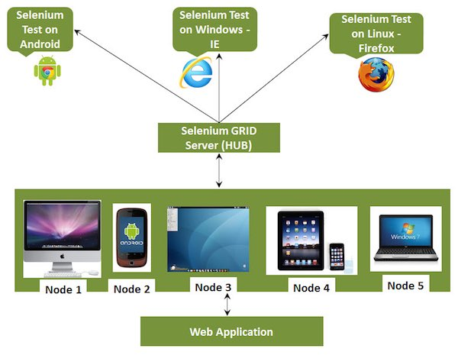

What are steps involved in the setting up the selenium grid ?

* Configuring the Hub
* Configuring the Nodes
* Develop the Script and Prepare the XML File
* Test Execution
* Result Analysis

Configuring the Hub?

Go the hub machine download and keep the jar file

And now start the hub in the machine by launching the below command

Java –jar selenium-standalonesever.jar –role hub –port any portnumber

You can check the status of the server by http:localhost:portnumber /grid/console to check the console

How to start the node

Log in to the machine where you want to run the node

On the command line

Java –jar selenium-standaloneserver.jar –role node –port 5555 –hub http:10.55.106.345:protnumer/grid/register –browser –browsername=firefox

How to set up the ie/chrome browser as the node machine

Java –Dwebdriver.chrome.driver=D\IEDriver.exe D\work\selenium-jar\selenium-standaloneserver.jar –role node –hub <http://10.47.117.235:5555/grid/register> -browser browserName=ie –version=7

Java –Dwebdriver.chrome.driver=D\chrome.exe D\work\selenium-jar\selenium-standaloneserver.jar –role node –hub <http://10.47.117.235:5555/grid/register> -browser browserName=chrome –version=7 paltform=Linux